MACHINE LEARNING ASSIGNMENT

Group – 8

Project Topic

Use the 'Real E-state Valuation’ database:

use linear regression, and logistic regression to justify the outcome using the database.

Code Implementation

**#Importing necessary libraries**

import pandas as pd

import numpy as np

import seaborn as sns

import matplotlib.pyplot as plt

from sklearn.preprocessing import StandardScaler

from sklearn.model_selection import train_test_split

from sklearn.linear_model import LinearRegression, LogisticRegression

from sklearn.model_selection import GridSearchCV

from sklearn.metrics import root_mean_squared_error, r2_score, accuracy_score, precision_score, recall_score, f1_score, mean_absolute_error

**# Importing the dataset**

df = pd.read_excel('real_estate_valuation.xlsx', index_col=0)

df

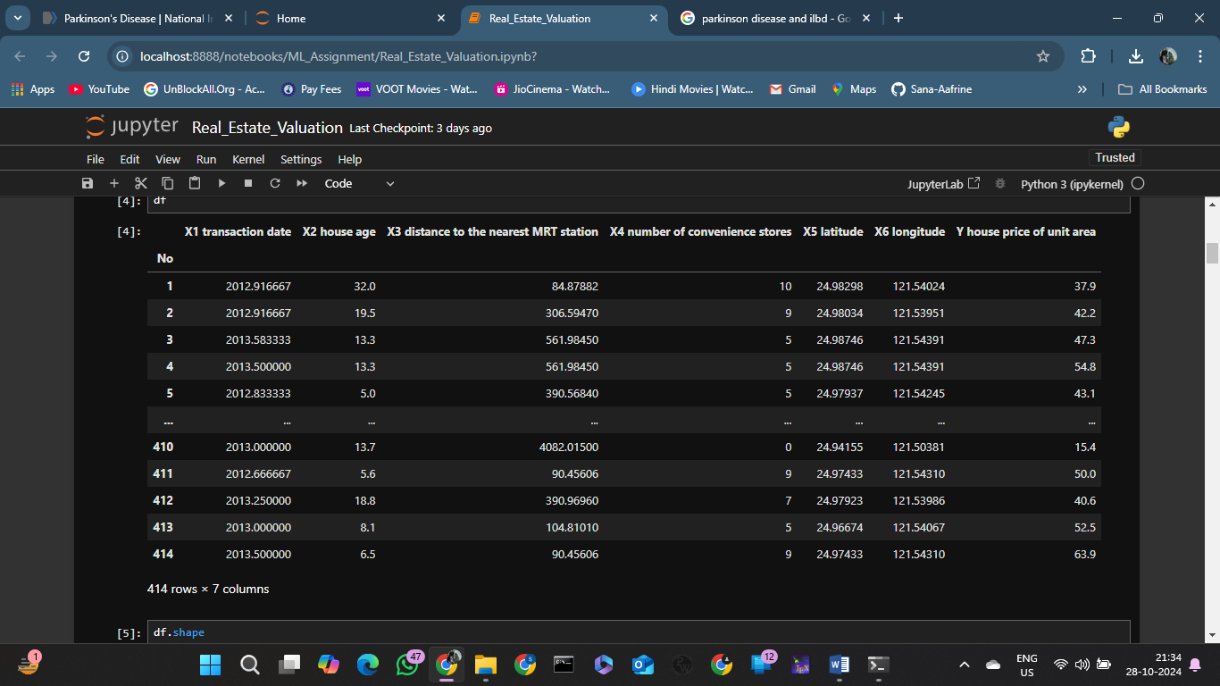

**#Analyzing the dataset**

df.shape

df.describe()

df.info()

**#Finding missing values**

df.isna().sum()

**#Extracting transaction year and dropping transaction date**

df['transaction year'] = df['X1 transaction date'].apply(lambda x: int(x))

df = df.drop(columns = 'X1 transaction date')

df.info()

**#Histogram plot to visualize distribution of data**

plt.figure(figsize=(15, 10))

for i, j in enumerate(df.columns, 1):

plt.subplot(4, 2, i)

sns.histplot(df[j], kde=True, bins=30)

plt.title(f'Distribution of {j}')

plt.xlabel(j)

plt.ylabel('Frequency')

plt.tight_layout()

plt.show()

**#Boxplot for better visualization of outliers in features and their spread**

plt.figure(figsize=(15, 10))

for i, j in enumerate(df.columns):

plt.subplot(3, 3, i+1)

sns.boxplot(x=df[j])

plt.title(f'Boxplot for {j}')

plt.tight_layout()

plt.show()

**#Logarithmic transformation of ‘distance to nearest MRT station’ to counteract skewness and handle outliers**

df['X3 distance to the nearest MRT station'] = np.log1p(df['X3 distance to the nearest MRT station'])

df['X3 distance to the nearest MRT station'].hist(bins=50)

sns.boxplot(x=df['X3 distance to the nearest MRT station'])

**#Forming a correlation matrix and generating a heatmap**

corr_matrix = df.corr()

sns.heatmap(corr_matrix, annot=True, cmap='coolwarm')

plt.show()

**#splitting data into 75-25% training and test set**

X = df.drop(columns = 'Y house price of unit area')

Y = df['Y house price of unit area']

X_train, X_test, Y_train, Y_test = train_test_split(X,Y,

test_size = 0.25,

random_state = 42)

**#Normalization of the features using StrandardScaler**

scaler = StandardScaler()

X_train_scaled = scaler.fit_transform(X_train)

X_test_scaled = scaler.transform(X_test)

**#Using GridSearch to find the optimal parameters for linear regression**

linear_regression_params = {

'fit_intercept': [True, False],

'copy_X': [True, False]

}

linear_regression_grid = GridSearchCV(estimator=LinearRegression(), param_grid=linear_regression_params,

scoring='r2', cv=5, n_jobs=-1)

linear_regression_grid.fit(X_train_scaled, Y_train)

best_lr_model = linear_regression_grid.best_estimator_

best_lr_params = linear_regression_grid.best_params_

print("Best Linear Regression Parameters:", best_lr_params)

**#Linear regression with optimal parameters**

lin_reg = LinearRegression() #default hyperparameter settings are found to be the best

lin_reg.fit(X_train_scaled, Y_train)

y_pred_linear = lin_reg.predict(X_test_scaled)

**#Evaluation of linear regression model**

linear_rmse = root_mean_squared_error(Y_test, y_pred_linear)

linear_r2 = r2_score(Y_test, y_pred_linear)

linear_mae = mean_absolute_error(Y_test, y_pred_linear)

print(f'Root Mean Squared Error : {linear_rmse}\nR2-score : {linear_r2}\nMean Absolute Error : {linear_mae}')

**#Binarization of target value**

median_price = Y_train.median()

y_train_binary = (Y_train >= median_price).astype(int)

y_test_binary = (Y_test >= median_price).astype(int)

**#Using GridSearch to find optimal parameters for logistic regression model**

logistic_regression_params = {

'max_iter' : [1000, 5000, 10000]

}

logistic_regression_grid = GridSearchCV(estimator=LogisticRegression(random_state = 42), param_grid=logistic_regression_params,

scoring='accuracy', cv=5, n_jobs=-1)

logistic_regression_grid.fit(X_train_scaled, y_train_binary)

best_log_model = logistic_regression_grid.best_estimator_

best_log_params = logistic_regression_grid.best_params_

print("Best Linear Regression Parameters:", best_log_params)

**#Logistic regression with optimal parameters**

log_reg = LogisticRegression(max_iter=1000, class_weight = 'balanced', random_state=42)

log_reg.fit(X_train_scaled, y_train_binary)

y_pred_logistic = log_reg.predict(X_test_scaled)

**#Evaluation of logistic regression model**

logistic_accuracy = accuracy_score(y_test_binary, y_pred_logistic)

logistic_precision = precision_score(y_test_binary, y_pred_logistic)

logistic_recall = recall_score(y_test_binary, y_pred_logistic)

logistic_f1 = f1_score(y_test_binary, y_pred_logistic)

print(f'Accuracy : {logistic_accuracy}\nPrecision : {logistic_precision}\nRecall : {logistic_recall}\nF1-score : {logistic_f1}')

**#Printing results of both models in table format**

performance_results = {

'Metric': [

'Root Mean Squared Error',

'Mean Absolute Error',

'R^2 Score',

'Accuracy',

'Precision',

'Recall',

'F1 Score'

],

'Linear Regression': [

linear_rmse,

linear_mae,

linear_r2,

None, # No value for linear regression metrics

None,

None,

None

],

'Logistic Regression': [

None, # No value for logistic regression metrics

None,

None,

logistic_accuracy,

logistic_precision,

logistic_recall,

logistic_f1

]

}

results_df = pd.DataFrame(performance_results)

results_df

